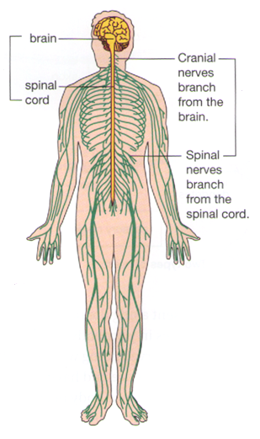
The Nervous System
The communication system which controls all parts of your body

The Human Nervous System
The human nervous system has two main parts:
- The central nervous system
- The peripheral nervous system

Label these on the diagram.
The central nervous system (CNS) _______________________________________________________
The peripheral nervous system _________________________________________________________
___________________________________________________________________________________
The CNS receives information from ______________________________________________________
___________________________________________________________________________________

Nerve Cells
The nervous system is _________________________________________________________________
Neurones carry ______________________________________________________________________

Motor Neurones
Motor neurones carry _________________________________________________________________
___________________________________________________________________________________
___________________________________________________________________________________
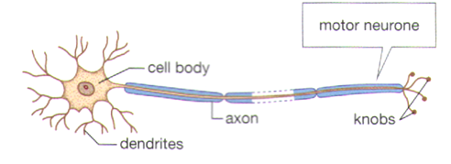

Sensory Neurones
Sensory neurones carry _______________________________________________________________
___________________________________________________________________________________
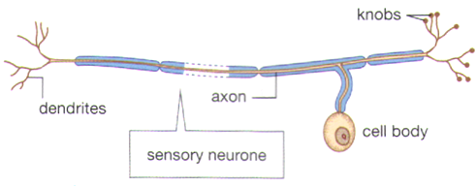

Parts of a Nerve Cell
The cell body ________________________________________________________________________
___________________________________________________________________________________

The dendrites _______________________________________________________________________
___________________________________________________________________________________

The axon ___________________________________________________________________________
___________________________________________________________________________________

The knobs __________________________________________________________________________
___________________________________________________________________________________

Sending Messages
The messages sent __________________________________________________________________
__________________________________________________________________________________

Your body needs to ___________________________________________________________________
___________________________________________________________________________________

If all the neurones in your body touched one another, stimulating one nerve ending would be like turning on one switch in your house and having all the lights and appliances turn on at once.

When the electrical impulse reaches the knobs, a chemical called a ______________________ is released into the space between the neurones.

This space __________________________________________________________________________

The neurotransmitter carries the message ________________________________________________
___________________________________________________________________________________

Nerves
In your body, _______________________________________________________________________

The neurones are ____________________________________________________________________

The myelin sheath ___________________________________________________________________

